CPSC 230 – Computer Science I

Fall 2020

Examination I

This examination is closed book and notes. There are 8 problems and 70 points possible. You have 75 minutes to earn as many points as you can. Good luck!

.

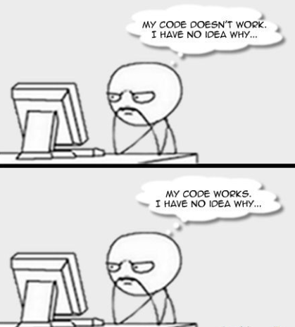

1. **(5 Points)** Answer the following:
2. Python is a(n) ___________________ language.
3. Write the command to run a Python program, welcome.py, from the terminal.
4. What is the integer remainder operator?

%

1. When using the input function, by default, what is the type of the object created?

STRING

1. **(10 Points)** Convert the following to binary/decimal as specified.
2. 225 to binary

11100001

1. 66 to binary
2. 512 to binary
3. 110110 to decimal
4. 1100101 to decimal
5. **(10 points)** Write a Python module that prompts the user for three numbers and prints “all the same!” if they are all the same, “all different” if they are all different, and “neither” otherwise.
6. **(10 points)** Write a Python module that prompts the user for two numbers and displays the average of those two numbers.
7. **(10 points)** Write a program and ask the user if they want to count up by 2 from zero or count down by 2 from 10 and depending on the answer display the numbers.
8. **(10 points)** The following program is attempting to find the volume of a cone (volume = 1/3πhr2). However, there are runtime and stylistic mistakes. Indicate on which lines and what the errors are that occur, there are 5 total. Then, rewrite the program below with all corrections fixed.
9. radius = input("Enter the radius: ")
10. height = int(input("Enter the height: "))
11. import math
12. volume = 1/3(PI)(height)(radius^2)
13. print("The volume of the cone is: ", volume)
14. **(10 points)** Use math functions to calculate the distance between two points. Assign point_dist with the distance between point (x1, y1) and point (x2, y2). The calculation is:

Distance = SquareRootOf( (x2 - x1)2 + (y2 - y1)2 ).

1. **(5 points)** (NO PENALTY FOR CONSTRUCTIVE CRITICISM.)

What is your impression of the course so far?

What have you enjoyed most about this course so far?

Is there anything you would like to see changed in the course content or the instructor teaching style?